617 Surry Street • Wilmington, NC • 28401 • 910.762.5606 • www.cfrw.us

BOARD OF DIRECTORS
1. The Effects of Groundwater Withdrawal and Disposal
Cape Fear River Watch (CFRW) is a non-profit organization dedicated to the protection and improvement of the health and water quality of the Lower Cape Fear River Basin through education, advocacy, and action. With this mission in mind, we have carefully considered and evaluated the potential impacts associated with Carolina Cement Company’s (Titan America) plans to develop a cement plant and mining operation in New Hanover County.

We have determined that this proposed industry, which would be situated along the banks of the Northeast Cape Fear River (NECFR), would cause irreversible harm to the natural resources and ecosystems that surround the proposed plant site. Existing natural resources include the surface water, groundwater, pristine freshwater wetlands, bottomland hardwoods, and habitat for Federally threatened and endangered species.

For these reasons, CFRW has taken a position strongly against the development and construction of this proposed project. CFRW has previously offered detailed concerns about the air quality permit and potential emissions that will be generated by the plant. We also believe the water issues, as discussed in the following pages, to be of equal or even greater concern as these will potentially significantly impact groundwater, surface water, and other existing natural resources.

Although it is difficult to comment specifically about potential impacts of the proposed operation as a detailed plan has not been submitted, there are some generalities and questions that we would like the permitting agencies to consider. CFRW is specifically concerned about the following environmental impacts that pertain to the water quality and ecosystem health of the Lower Cape Fear River Basin:

Protecting and improving the water quality of the Lower Cape Fear River Basin
through Education, Advocacy, and Action

We are a 501(c)3 nonprofit. Tax ID#58-2121884.
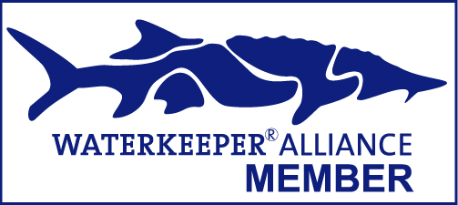
Elise Rocks
President
Arthur Brownell
Vice President
Alan Cradick
Secretary
Brent McAbee
Treasurer

Julia Berger
Lara Berkley
Jim Bitto
Larry Cahoon
Gordon Johnson
Melissa Juhan
Jeannie Lennon
Jot Owens
Ted Richman
Brad Rosov
Marty Rowan
Roger Shew
Doug Springer
Tom Tewey
Dawn York

STAFF
Kemp Burdette
CAPE FEAR RIVERKEEPER®
and Executive Director

Stephanie Borrett
Resource Director

Jennifer Cole
Communications Coordinator

Kay Lynn Plummer-Hernandez
Education Specialist

Scott Whitham
Greenfield Lake Manager

The mining of the Castle Hayne Limestone and probably the Peedee Formation will require the handling and disposal of large volumes of water. Mining in an area where the water table is near the surface demands pumping of the water from the pits to keep them open. It has been estimated that 9 – 16 million gallons of water will have to be pumped and disposed of daily, which creates several issues.

a. Pumping large volumes of water will lower the water table within the Castle Hayne.

The Castle Hayne Limestone is present at the surface (unconfined aquifer) in the mine area. The water withdrawal will lead to the formation of a cone of depression (Figure 1) that may easily be 10’s of feet deep and may extend outward for several thousands of feet to well over a mile.

Detailed field measurements and calculations utilizing storage potential (porosity), transmissivity (measure of the volume of water flowing through a cross-sectional area of the aquifer), and recharge rates need to be done to assess the actual values, but based on the volume of water to be removed daily a large cone of depression is likely that may have potentially large impacts on the surrounding area.

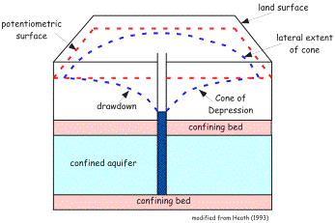

Figure 1 - A cone of depression forms with water removal. The depth and width of the cone of depression are governed by the rate and amount of water withdrawal and by the formation’s storage potential, transmissivity, and recharge.
(from www.ncwater.org/Education_and_Technical_Assistance/Ground_Water/Hydrogeology).

What is/are the result(s) of this cone of depression? Perhaps the largest issue is the lowering of the water table that is critical to the surrounding freshwater wetlands (Figure 2) that occur adjacent to much of the subject mine area, particularly to the ENE toward Island Creek.

Lowering the water table, depending upon the extent of the cone of depression, may impact surrounding shallow water wells. However, other issues may include movement of contaminants (already present or that may be generated with the use of explosives) and creation of sinkholes.

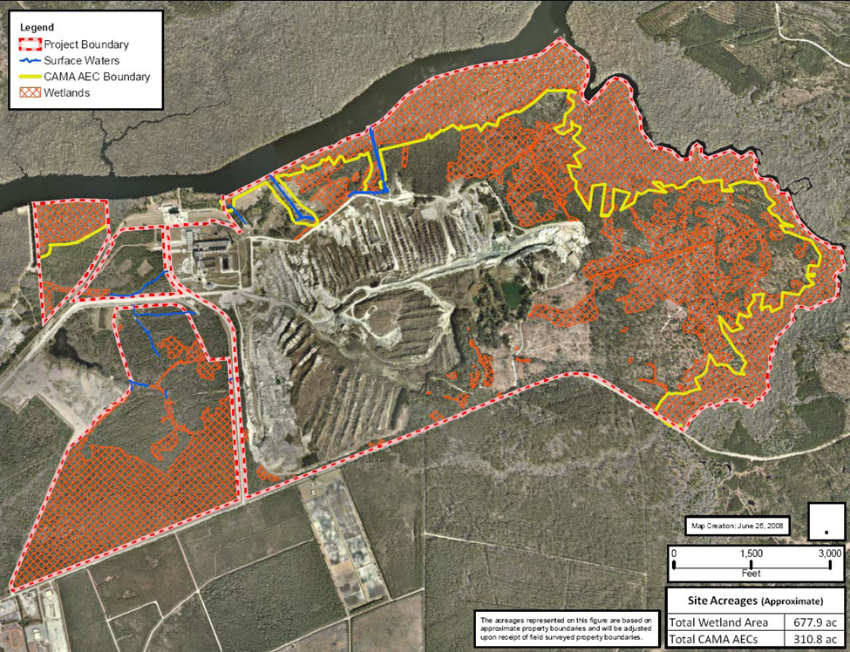

Figure 2 - The circle has a diameter of 6000 ft (1829 m) centered on the current mine area.
(modified from http://wwwdefault.nhcgov.com/website/environ/viewer.htm)

b. De-watering the pits for mining requires disposal of the formation waters

What will be done with the water – disposal in the NECFR, re-injection in the Castle Hayne, surface spreading, sales to public utilities, etc.?

All of these require special consideration to determine their impacts on the surrounding ecosystems, even the sales to public utilities, as this is net removal of groundwater from the area. The other disposal methods may change local hydrology that may directly or indirectly affect the adjacent ecosystems. Settling ponds will be necessary for the fines to settle out before disposal.

Because much of the potential mine site is within the 100 year floodplain (Zone AE – Figure 3), it is essential that plans are in place to prevent any floodwaters from carrying large volumes of silt from the settling ponds or spoil piles into the adjacent Island Creek and NECFR ecosystems.

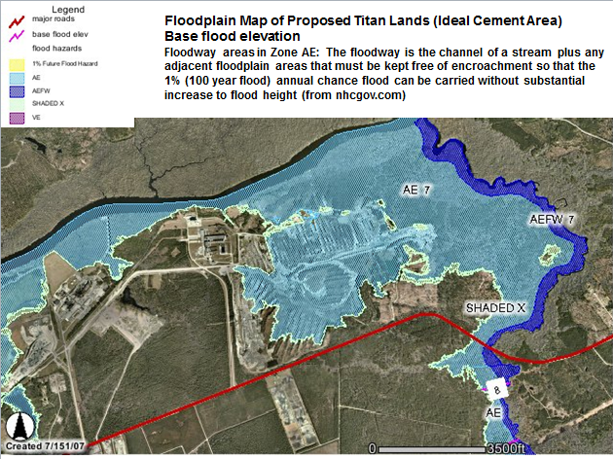

Figure 3 - The area shown in blue is the100 year flood outline relative to the mine area in New Hanover County. The flood area is not shown on the other side of the river as that is Pender County. (from http://wwwdefault.nhcgov.com/website/flood/viewer.htm)

2. Atmospheric Deposition of Mercury and Other Heavy Metals

The Northeast Cape Fear River is classified as being mercury impaired on the Federal 303(d) list from Highway 210 to Prince George Creek. This stretch of water does not meet the water Class B and Sw (swamp waters) intended water usages, being impaired for fish consumption.

Therefore, though there is some debate as to the rule of law with air emissions impacting the water, we believe that any additional atmospheric deposition of mercury should not be allowed as it will further impair an already impaired water source and potentially further harm sensitive ecosystems proximal to the plant operations. Though not currently impaired for other metals, models should be run to determine if there is potential for harm to the NECFR from other emissions.
3. Possible Loss of Spawning Habitat for Fish Species

The NECFR is home to numerous species including the anadromous fish striped bass, American shad, and the Atlantic sturgeon, which have been known to use the river as spawning habitat. Baseline assessments should be conducted to document the former and current presence and use of the waters by these and other species prior to any plant construction.

4. Management of on-Site Wastewater and Stormwater
The construction of the plant and quarry will necessitate the treatment and disposal of large volumes of wastewater and stormwater. We ask that a rigorous plan of treatment and disposal of wastewater be in place that would assure “no harm” to the NECFR and result in no discharge to the river. Likewise, stormwater runoff must be handled carefully; it is imperative that all efforts be made to eliminate any possibility of water or habitat degradation that might be caused by increased turbidity, total suspended solids, phosphate, pH, etc.
5. Transportation-related impacts

Additional infrastructure will be required including roads for truck transport, rail, and/or barge traffic to handle the more than 2 million tons of cement annually. This could impact the surface water quality as well as recharge of the Castle Hayne. Additional dust, impervious surfaces, and barriers to surface water flow could lead to more impaired and channeled stormwater.

Conclusion

With these concerns in mind, and with the many others associated with air quality and sensitive ecosystems, we believe the proposed site for the Titan facility on the NECFR should not be permitted – there are just too many issues and questions about the plant operation and there is certainly too much at stake with the potential loss or impairment of valuable natural ecosystems in and adjacent to the Northeast Cape Fear River.

